

**InstaStay: A Modern Hotel**

**Booking Platform**

A seamless MERN stack solution for effortless hotel discovery, booking,

and management



**Platform Overview**

**What Is InstaStay?**

InstaStay is a comprehensive hotel

booking platform built with the MERN

stack, designed to deliver an intuitive

and secure booking experience. The

platform connects travellers with

accommodations whilst providing hotel

owners with powerful management

tools.

**Key Highlights:**

Seamless hotel search and booking

Secure payment processing

Mobile-responsive design

Real-time availability tracking

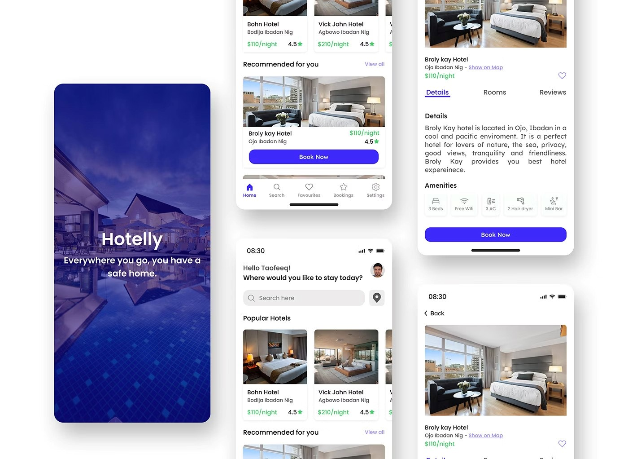

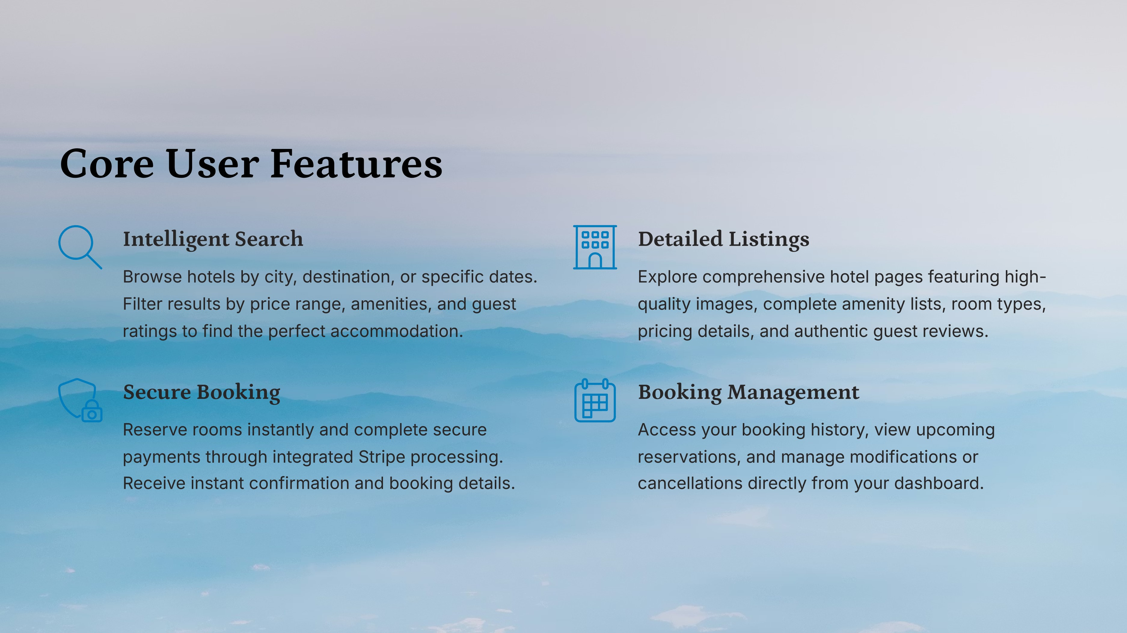



**Administrator Capabilities**

**Hotel Management**

Add new properties, update existing

listings, modify room details, and

remove hotels as needed. Full

control over property information

and availability.

**Availability Control**

View real-time booking calendars,

block dates for maintenance, and

adjust room availability to reflect

current inventory and seasonal

changes.

**Booking Oversight**

Monitor all reservations, track guest

information, process cancellations,

and manage special requests.

Complete visibility into booking

activity.



**Technology Stack**

Built with modern, industry-standard technologies ensuring reliability, scalability, and maintainability

**Frontend**

React.js for component-based

UI

Bootstrap framework

CSS3 for styling

Responsive design principles

**Backend**

Node.js runtime

Express.js framework

RESTful API architecture

JWT authentication

**Database**

MongoDB (NoSQL)

Atlas cloud hosting

Flexible schema design

Efficient data querying



**Security & Payment Integration**

**Secure Payment Processing**

InstaStay integrates Stripe, a PCI-compliant payment gateway trusted by

millions of businesses worldwide. All transactions are encrypted and processed

securely, ensuring guest payment information remains protected.

**Authentication & Security**

JSON Web Tokens (JWT) provide stateless authentication, ensuring secure user

sessions. Passwords are hashed using industry-standard bcrypt algorithms,

protecting user credentials whilst maintaining system performance.



**Visual Experience & Media**



**Cloudinary Image Management**

High-performance image hosting and delivery ensures fast

loading times. Automatic optimization, responsive images,

and CDN distribution deliver crisp visuals across all devices.



**Rich Media Experience**

Multiple high-quality images per listing showcase amenities,

rooms, and facilities. Gallery views allow guests to explore

properties visually before booking.



**Responsive Design**

**Principles**

**Mobile-First**

Optimized touch interfaces and streamlined navigation for

smartphones

**Tablet Ready**

Adaptive layouts that maximize screen real estate on tablets

**Desktop Power**

Full-featured experience with advanced filtering and

management capabilities

The platform adapts seamlessly to any screen size, ensuring consistent

performance and usability across all devices. Fast loading times and

intuitive interfaces keep users engaged.



**Deployment & Infrastructure**

**Frontend Hosting**

Vercel provides lightning-fast global

CDN delivery, automatic SSL

certificates, and instant cache

invalidation for optimal frontend

performance.

**Backend Services**

Render hosts the Node.js backend

with auto-scaling capabilities,

ensuring reliable API availability and

handling traffic spikes efficiently.

**Database Layer**

MongoDB Atlas delivers managed

database services with automated

backups, monitoring, and global

replication for data durability.



**Key Benefits & Value Proposition**

**Fast Time to Market**

Modern MERN stack enables rapid development and

deployment with reusable components and efficient

development workflows.

**Scalable Architecture**

Cloud-native infrastructure and NoSQL database

design allow horizontal scaling as user base and hotel

inventory grow.

**Enhanced User Experience**

Responsive design, fast performance, and intuitive

interfaces create seamless booking experiences that

drive conversions.

**Reduced Maintenance**

Managed services for frontend, backend, and

database minimize operational overhead whilst

ensuring platform reliability.



**Future Scope & Roadmap**

Exploring potential enhancements and strategic growth areas for InstaStay to further revolutionize hotel booking and

management.

**Advanced Features**

AI-powered personalization for

hotel recommendations.

Dynamic pricing algorithms to

optimize revenue.

Integrated loyalty programs to

reward frequent guests.

**Expansion Plans**

Multi-language support for

global accessibility.

Integration of diverse

international payment methods.

Development of dedicated iOS

and Android mobile apps.

**Analytics & Insights**

Deep guest behavior analytics

for improved targeting.

Revenue optimization tools and

forecasting.

Customizable performance

dashboards for hotel owners.